Assignment - 3 **Scripting Languages Assignments**

Eshwar Reddy Yasa - **19265A0512**  
6th April, 2021

**A1. Write a ruby program using upto iterator method for a block(using do & end).** **3**

**A2. Write a ruby program using hashes (the key –value pair should be cars and their respective brand) and print all the list of key –value pairs.** **4**

**A3. Write the ruby program given on slide 61.** **5**

**Write the ruby program given on slide 67** **6**

**Write the ruby program given on slide 76** **7**

# A1. Write a ruby program using upto iterator method for a block(using do & end).

**Program**

1.upto(10) do |i|

print i

end

**Output**

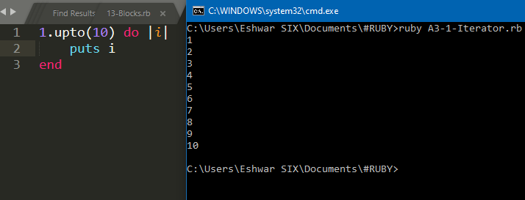

# A2. Write a ruby program using hashes (the key –value pair should be cars and their respective brand) and print all the list of key –value pairs.

**Program**

cars = {

"Swift" => "Maruti Suzuki",

"Elite i20" => "Hyundai",

"Scorpio" => "Mahindra",

"Tiago" => "Tata Motors"

}

cars.each do | carmodel, carbrand |

puts "#{carmodel} belong to #{carbrand}"

end

**Output**

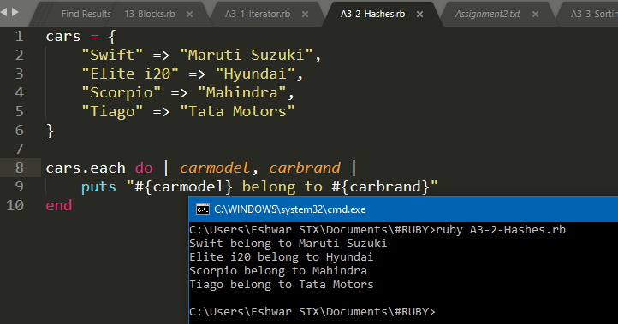

# A3. Write the ruby program given on slide 61.

**Program**

#Sorting in Arrays & Hash

puts "\n--Hash-----------------------------------------------"

h = {"B" => "Break", "A" =>"Array", "C" => "Case"}

print("#{h}\n")

print("#{h.sort}\n")

puts "\n--Array-----------------------------------------------"

a = [5, 6.7, 1.2, 8]

print("#{a}\n")

print("#{a.sort}\n")

print("#{a.sort!}\n")

a[4] = "Hello"

print("#{a.sort}")

**Output**

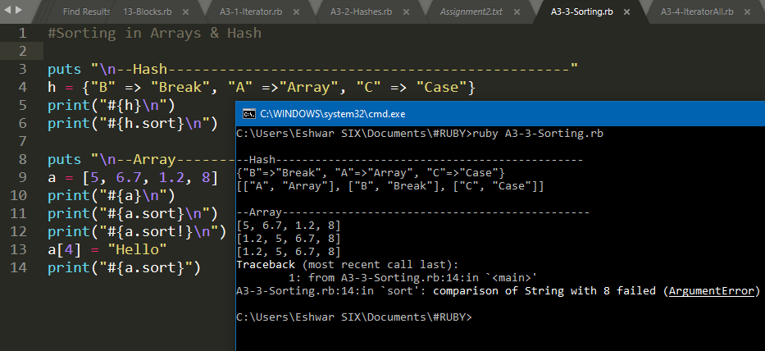

# A4. Write the ruby program given on slide 67

**Program**

puts "Find 1st matching perfect square"

puts([1,2,3,4,5,6,7,8,9].find{ |n| Math.sqrt(n).remainder(1)==0})

puts "Select perfect squares"

puts([1,2,3,4,5,6,7,8,9].select{ |n| Math.sqrt(n).remainder(1)==0})

puts "Prints array"

[6,2,8,4,0].each { |i| puts i }

puts "Square of nums"

[1,2,3,4,5].each { |i| puts i*i }

puts "Square of nums alternative"

(1..5).each{ |i| puts i*i }

**Output**

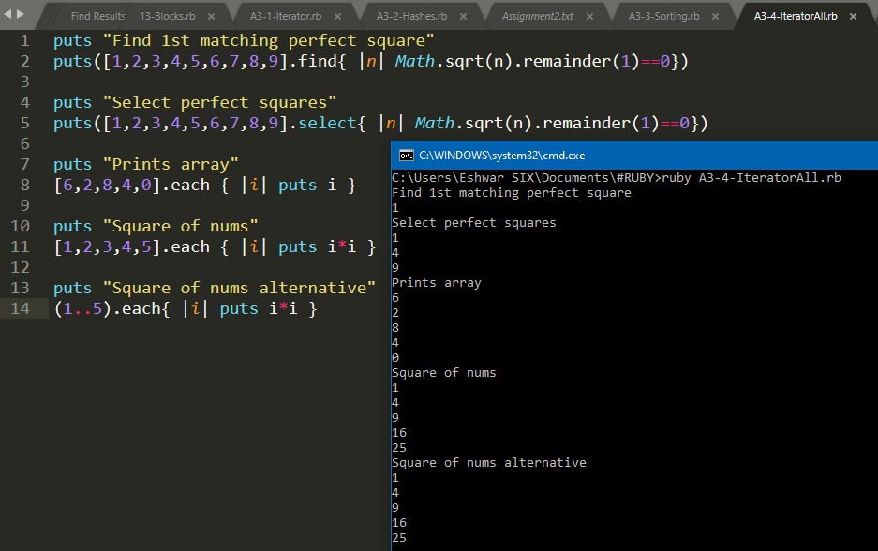

# A5. Write the ruby program given on slide 76

**Program**

def yield_sample

yield 2

yield "hello"

yield 3.7

end

yield_sample { |n| puts n * 3}

**Output**

